Probability and Statistics (MT-2005)

Project Report

Submitted to:
Ms. Rijah Khan
Submitted by:
Muhammad Abdullah (22i-2672)
Muhammad Ismail (22i-2438)
BS-SE(E)

Contents
1.Introducton 3
2.Literature Review 4
3. Regression Model and Variables 5
3.1 Description 5
4.Description, Results and Discussion 6
4.1.General overview 6
Following is the summary of the data, 6
4.3. Task 3 7
4.4 Task 4 9
5.References 13
Works Cited 13

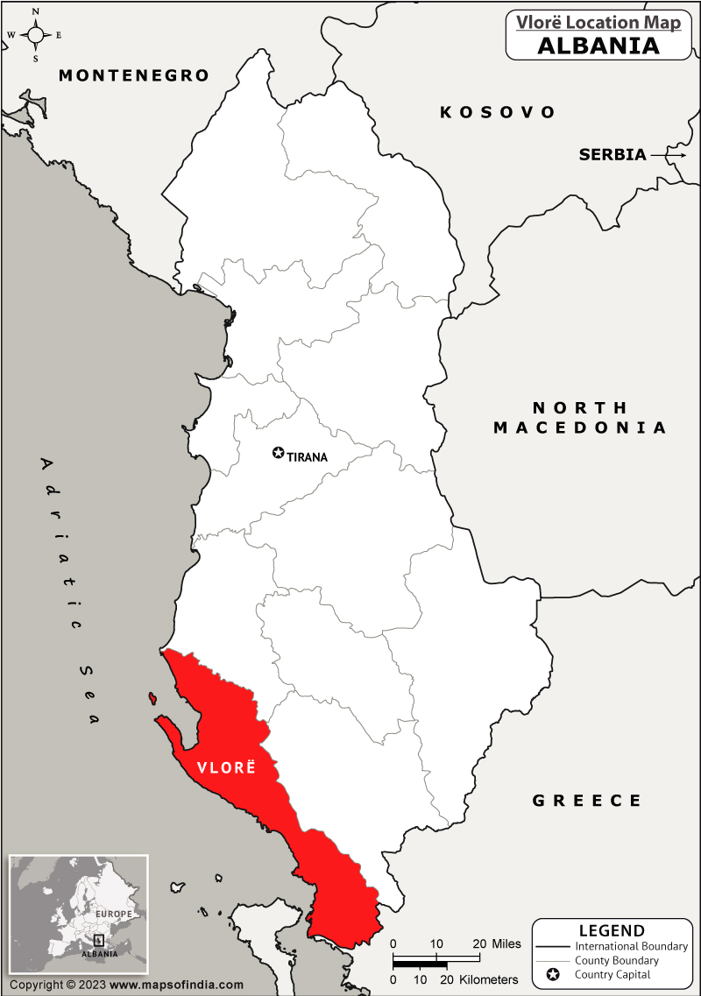

1.Introducton
The purpose of this document is to report on the research correlating precipitation with other environmental factors. The project aims to utilize the potential of R-language and Studio in data analysis. It is another exuberant example of how probability and statistical analysis can help solve real world problems.

For our research we have used a dataset from Kaggle (Allushi, n.d.). The dataset showcases sufficive weather data from the coastal city of Vlore, Albania. It holds average temperature, minimum temperature, maximum temperature, wind direction, wind speed, millimeters of precipitation, and the pascals of pressure experienced by the city throughout 2021. Our regression model is strictly a preliminary research artefact, defined in the aim to aid a greater understanding of determining the precise measurement of precipitation and the precise date at which a city or a major metropolitan area would experience that precipitation.

2.Literature Review
The reservation of water has become an essential area of concern, now more than ever before. With the rising global temperature and climate change, the word’s water only becomes a more vital and a greater pivot. It is reported that water scarcity effects 1/5th of the world’s population (www.un.org, 2015).
Only 3% of natural water resources is drinking water, of which 20% is trapped in glaciers which are melting, leading to flooding, putting a greater stress on available water resources. In the midst of a water crisis, rainwater can as a reliable water reserve. Many people have already started using rainwater for menial tasks such as for flushing and washing purposes. However, there’s great potential in the utilization of rainwater, and this regression model is certainly a greater step in a revolutionary direction. At a domestic level, rainwater harvesting allows households to become less reliant on municipal water supplies and can provide a sustainable secondary water source for gardening, washing cars, flushing toilets, and even laundry with proper treatment. Moreover, it reduces water bills and the strain on shared water resources.

Commercially, rainwater harvesting can be a game-changer. Industries such as agriculture, which require significant amounts of water, can substantially reduce their operational costs and reliance on external water supplies. Moreover, properties like hotels and office buildings can use harvested rainwater for landscaping and sanitation purposes, promoting sustainability while reducing overheads. (Rainwater as a solution to water scarcity: case studies from around the world, 2024)

3. Regression Model and Variables
In our research for the project we applied many regression models to explore the relationships between the contents of the weather of Vlore. In our model, we kept the Precipitation experienced each day in millimeters as independent, other factors such as maximum temperature, wind speed, atmospheric pressure, wind direction and minimum.

3.1 Description
Precipitation (mm) : the millimeters of rainfall experienced every day.
Maximum Temperature (*C): the highest recorded temperature of the day.
Minimum Temperature (*C): the lowest recorded temperature of the day.
Wind Speed (Km/h): how fast the wind is blowing every day.
Wind Direction: the direction in which the wind is blowing
Pressure (Pascals) : the atmospheric pressure on a given day.
All data is accurate to the city of Vlore, Albania circa 2021.
We quantify that, that these variables have a relation with precipitation experienced by the city.

4.Description, Results and Discussion
4.1.General overview
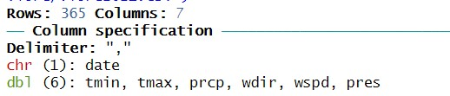

The names of the variables are shortened.
4.2. Task2
Following is the summary of the data,
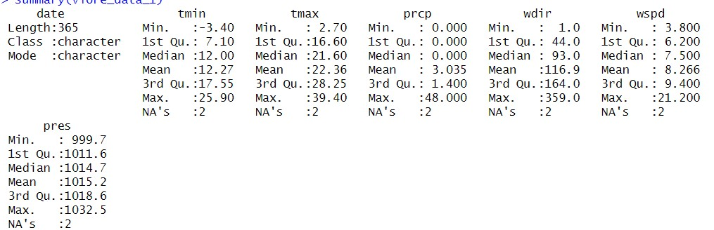
For more accurate and purposeful data set, we excluded days when Vlore experience less than 1 mm of precipitation.

> vlore_data_filtered <- vlore_data_1 %>%
+ filter(prcp >= 1)
the modes of the filtered data:
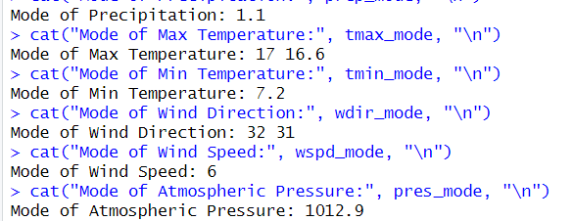
- The mode values of all involved datasets, point towards Vlore’s coastal climate, however the 16.6 *C maximum temperature suggests the city is chillier than most and 7.2 *C minimum temperature mode confirms modernity.
- Clearly, not as windy with only 6, but it is higher than most cities.
- Normal Precipitation mode, but the data has clear outliers and we have studied these

4.3. Task 3
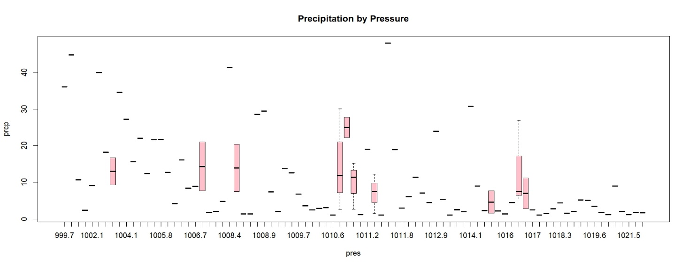

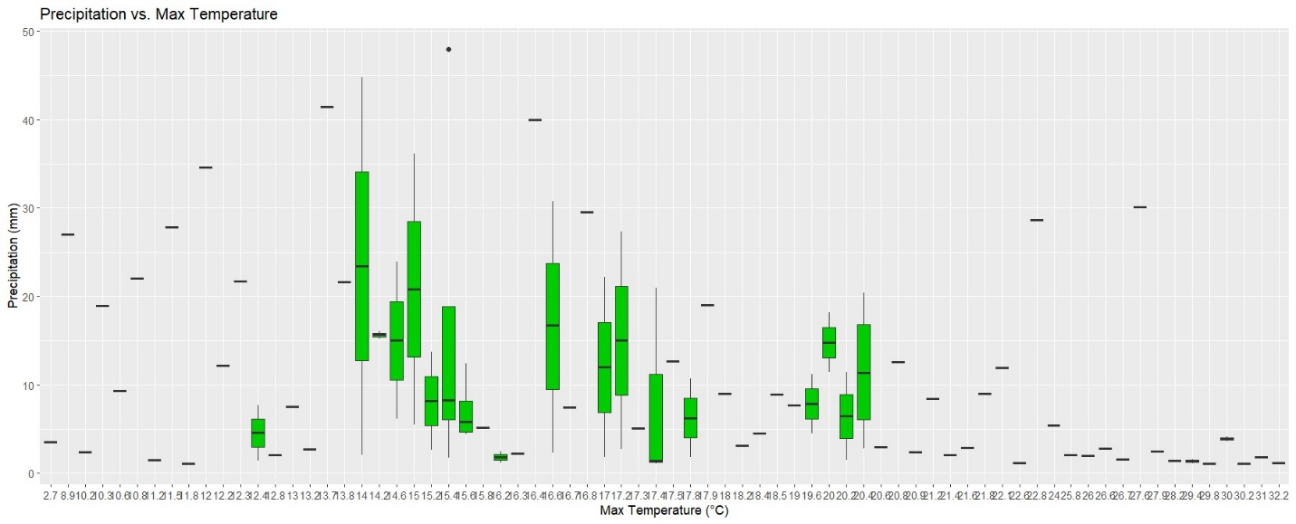
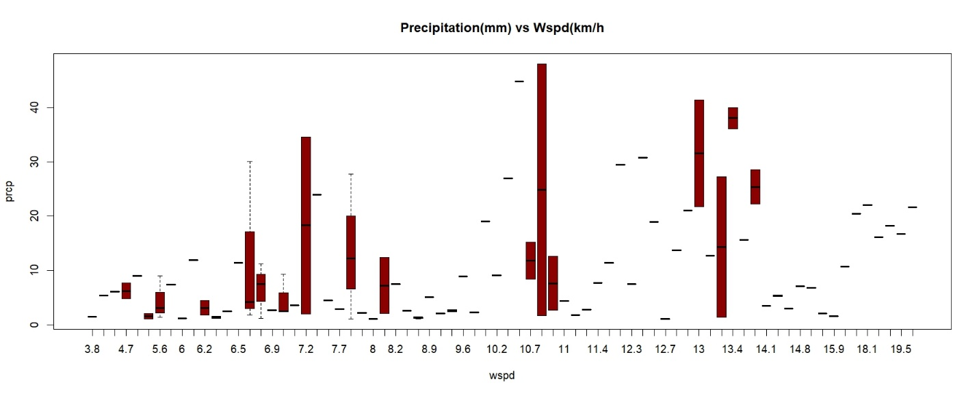
The longest whisker suggest the wind speeds, pressures and temperature for which vlore experince th elarest range of precipitation. The outliers are the values for which there is precipitation, but outside of the IQR. The single plots are for the values, when there usually isn’t any precipitation, and it was a singular occurrence.

4.4 Task 4
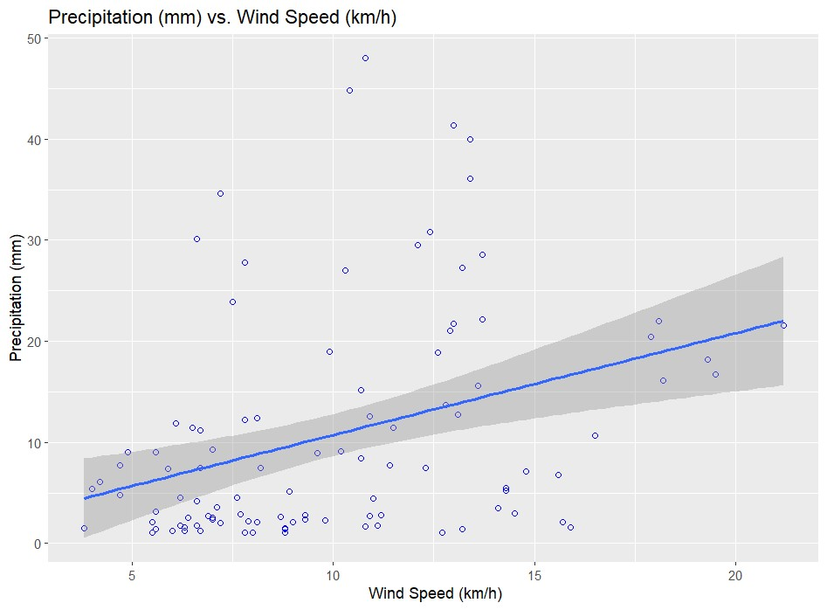
Coefficient of determination: 0.12
Weaker correlation, but in general
a windy rainy-day experiences more precipitation than the still rainy day
.
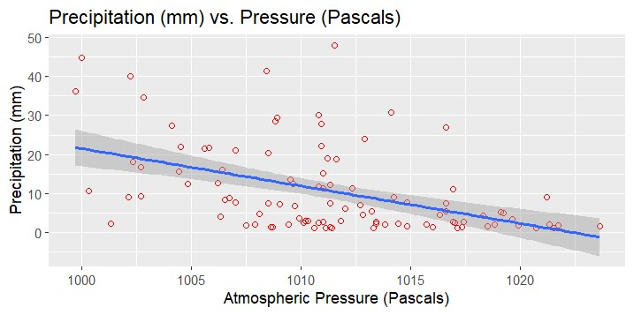
Coefficient of determination: 0.22
Suggest a weaker correlation, because precipitation is largely affected by other factors, not available in the dataset. In general, we can say the rainfall, when atmospheric pressure is higher, will yield less precipitation.
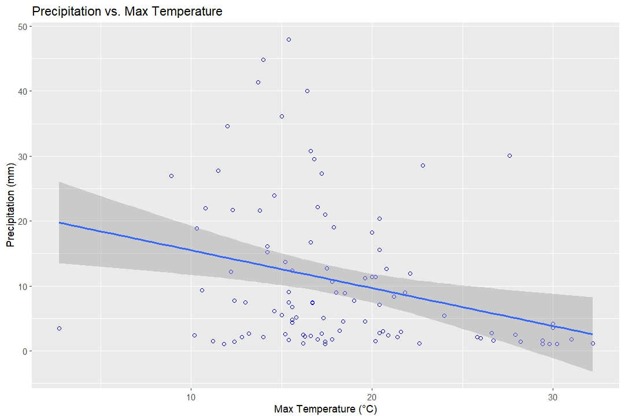
Coefficient of Determination: 0.167
Negative correlation, and this is also weak, because factors unrecorded have a greater influence on the precipitation e.g(frequency of precipitation, and the amount of water vapor in the air relevant to windspeed). In general, on rainy days with higher max temperature the precipitation is lower than on rainy days with a lower max temperature.

RM with two independent variables:
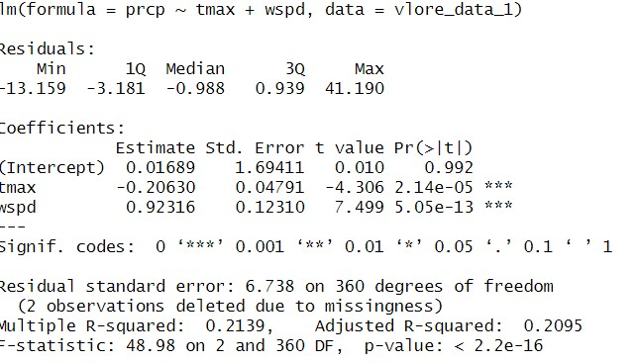
RM with more than two independent variables:
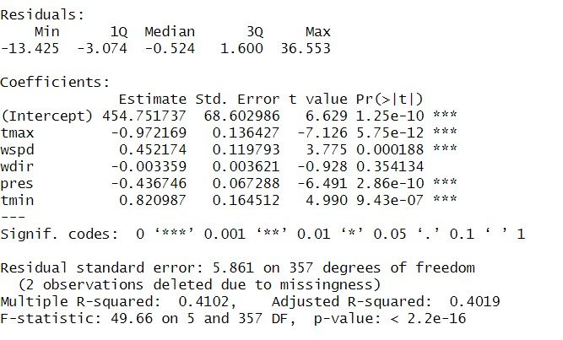
In this case wind direction is an insignificant variable

5.References

Works Cited
(2015). Retrieved from www.un.org: https://www.un.org/waterforlifedecade/scarcity.shtml
Allushi, M. (n.d.). Weather of Albanian cities in the last 3 years. Retrieved from Kaggle: https://www.kaggle.com/datasets/gucci1337/weather-of-albania-last-three-years/code
Rainwater as a solution to water scarcity: case studies from around the world. (2024, May 11). Retrieved from smartwateronline.com: https://smartwateronline.com/news/rainwater-as-a-solution-to-water-scarcity-case-studies-from-around-the-world#:~:text=Utilising%20rainwater%20tanks%2C%20homeowners%20can,down%20on%20household%20water%20bills.

